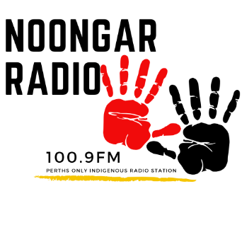

Expression of Interest

Noongar Radio Volunteer

Name:
Age: Please Circle: Male / Female / Other
Phone: Email:
Do you identify as Aboriginal or Torres Strait Islander?
No Aboriginal Torres Strait Islander Both
Please Tick your area of Interest/s:
Presenter - Live or Recorded Programs
Producer – Support broadcasters [arrange guests, editing, research, etc]
Station Helper – Typing, research, gardening, promotion, editing, etc.
Outside Broadcast Event Assistant
YouTube – Assisting and helping in creating content for Noongar Radio’s YouTube Channel
Other [Please Specify]

Do you have any qualifications or special interests you would like us to know about?
[You may attach your resume]

Do you have any radio/media experience? [If yes, please provide more detail]

On receipt of your expression of interest our Volunteer Coordinator will be in contact to arrange an interview to discuss your interest to Volunteer at noongar radio.
207 Beaufort Street, Perth
T: [08] 9228 0606 E: info@noongarradio.com F: [08] 9228 3922
www.noongarradio.com
PO BOX 8462, PBC, 6849

